“Hybrid Deep Neural Architecture for Robust Activity Recognition from Wearable Sensor Data”

1st Suyash Pandey
G. L. A. University,
Mathura, Uttar Pradesh,
suyash.pandey_bca.ds23@gla.ac.in

3rd Tej Pratap Yadav

G. L. A. University

Mathura, Uttar Pradesh

tej.pratap_bca.ds23@gla.ac.in
2nd Tamnna Chaudhary
G. L. A. University,
Mathura, Uttar Pradesh,
tamnna.chaudhary_bca.ds23@gla.ac.in

4th Mr. Jayati Krishna Gowswami

Project Assistant
Department of Computer Engineering and Applications,
G. L. A. University
Mathura, India

Abstract— Human activity recognition with wearable sensors is becoming an integral part of digital health, fitness monitoring, and human-computer interaction. Despite the rapid progress, robust performance for classification remains a challenging task if the sensor data is limited, noisy, or heterogeneous. The presented study investigates how preprocessing strategies combined with optimized model architectures provide for dependable activity recognition based on a wearable-sensor dataset comprising around one thousand multivariate samples. Normalization, outlier correction, and feature refinement were applied in order to enhance the quality of the signals and reduce redundancy. Several machine-learning and deep-learning models were implemented, namely baseline classifiers and improved neural network architectures. Experimental analysis demonstrates that model performance depends on the quality of preprocessing and selection of discriminative features. Thus, an optimized deep-learning model provided a significant increase in the accuracy concerning baseline approaches; this fact points to the advantage of targeted hyper-parameter tuning in scenarios considering small-scale datasets. The study suggests the possibility of creating lightweight yet accurate systems for human activity recognition that can be exploited in resource-constrained wearable applications in real-world settings.
Index Terms— Human Activity Recognition (HAR); Wearable Sensors; Time-Series Classification; Deep Learning; Machine Learning; Sensor Data Processing; Feature Engineering; Model Optimization; Hyper-parameter Tuning; IoT-based Activity Monitoring; Digital Health Analytics.

- Introduction
Human Activity Recognition has been one of the most important areas of research in ubiquitous computing today, motivated by the rapid growth of wearable devices and sensor-based monitoring systems. Such wearable sensors as accelerometers, gyroscopes, and magnetometers can capture fine-grained continuous motion signals of human activities in an automated way. These are critical in many recent applications concerned with healthcare monitoring, assistance to the elderly, support for rehabilitation, fitness tracking, workplace safety, and personalized smart-home environments. Together with the increasing use of sensor-enabled devices in daily life, demand for both highly accurate and computationally efficient systems of HAR has grown significantly.[1]

Despite technological advances in sensing, developing robust models for HAR is by no means an easy process. Sensor signals are typically noisy and may vary significantly between different users, while device placement, orientation, and poor sampling may lead to further variations. Besides, several public or real-world datasets are relatively small, and most categories are imbalanced, exerting an adverse influence on model generalization. The traditional methods of machine learning depend a lot on handcrafted features and thus fail to determine complex temporal relations in multivariate sensor signals.[2] Therefore, deep learning, with its convolutional and recurrent neural networks, has now become preferred, as it learns the discriminative patterns directly from raw or minimally pre-processed data. However, in the case of wearable-sensor datasets, deep learning brings into play other challenges. Unlike large-scale vision or speech datasets, most HAR datasets are not particularly large; hence, there is a high risk of over-fitting. The effectiveness in this context depends on effective preprocessing and refinement of features, coupled with the optimal model architecture design. The recent literature has focused on the steps of normalization, handling outliers, segmentation, and dimensionality reduction as important ways to realize better classification accuracy. Furthermore, suitable tuning of hyper-parameters coupled with light model architecture leads to low computational complexity, making these HAR systems feasible for embedded or real-world applications.[3] The study aimed at proposing a robust activity recognition framework with efficient preprocessing and optimization techniques of models on wearable sensor data to suit small- to medium-scale datasets. It explored the various learning architectures and studied their performance through systematic experimentation to look for one that can balance accuracy, generalization, and computational efficiency. These outcomes add to the rich literature in sensor-based activity recognition and shed light on practical issues related to deploying HAR solutions in real wearable systems.

- Related Work

This section reviews the prior research on wearable-sensor-based Human Activity Recognition. The review is organized along the following thematic subsections:
(1) Classical Machine Learning Approaches and Feature Engineering
(2) Deep Learning Architectures for time-series sensor data
(3) Techniques Addressing Scenarios of Limited Data: data augmentation, transfer learning, few-shot and meta-learning
(4) Multimodal and Fusion Methods
(5) Common Challenges and Open Research Directions.

1. Classical Machine Learning and Feature Engineering

The majority of early HAR systems rely on handcrafted features extracted from inertial sensors (accelerometers, gyroscopes, magnetometers) followed by traditional classifiers such as k-Nearest Neighbors (k-NN), Support Vector Machines (SVM), Decision Trees, and Random Forests. Feature sets commonly include time-domain statistics, frequency-domain descriptors, and windowed temporal features such as zero-crossing rate and correlation between axes. These pipelines were small, interpretable, and computationally efficient, so they could be run on embedded devices. However, their performance was very sensitive to the quality of feature selection and could not capture complex temporal dependencies for longer windows.[4]

2. Deep Learning for Wearable-Sensor HAR

Deep-learning methods, on the contrary, became dominant with the increase of both computational resources and publicly available labeled datasets. Convolutional neural networks (1D-CNNs) achieved excellent performance regarding the extraction of local patterns from sensor streams and reduced the need for extensive handcrafting. In this regard, temporal dynamics and long-range dependencies were modeled with the highest performance using recurrent architectures such as LSTM and GRU. Hybrid models-convolutional layers combined with recurrent units (CNN-LSTM, CNN-GRU)-aimed to capture both local and temporal features and often outperformed other deep-learning approaches in terms of robustness on benchmark datasets. Transformer-based temporal encoders and residual 1D architectures have lately been investigated for deeper models to enhance gradient flow. These latter techniques consistently outperformed classical pipelines on many public HAR datasets when enough labeled data were available.[5]

3. Architectures and Design Considerations

Literature offers a large design space, ranging from shallow 1D-CNNs for lightweight embedded use, over deeper residual 1D networks, allowing for higher accuracy and stacked recurrent layers for temporal modeling. Several domain-specific modules have also been discussed, such as axis-wise convolution and sensor-channel attention, accounting for the particularities of inertial measurements. In practice, model selection often represents a trade-off between accuracy and latency, whereas memory is crucial for real-time wearable deployment. Comparisons of different architectures reveal that for moderate-size datasets, 1D-CNNs tuned with great care or compact ResNet variants can have performances equal to or even surpassing those of CNN-LSTM hybrids while maintaining a low inference cost. [6]

4. Handling Limited and Imbalanced Data

Wearable HAR research typically deals with small and imbalanced datasets. Widely adopted strategies include the following: a) signal-level data augmentation, such as but not limited to time warping, scaling, jittering, and rotation; b) generative approaches using adversarial models or variational methods to synthesize realistic sensor streams; and c) transfer learning or fine-tuning from larger related datasets. Automated augmentation frameworks and model-agnostic augmentation selection have been shown to help improve generalization. More recently, few-shot learning, and meta-learning approaches started to emerge as promising solutions for user-adaptive HAR, where labeled samples per subject are particularly scarce. [7]

5. Multimodal Fusion and Sensor Placement

Combining information from multiple sensor modalities or placements of sensors on the body increases discriminability, especially for activities dominated by subtle motion cues. Strategies for fusion range from early fusion-which means concatenation of channels at the input level-to late fusion, which involves an ensemble of modality-specific networks, and including a middle ground with attention mechanisms. Sensor placement variability remains one of the persistent challenges; several works addressed this via invariant feature learning, data augmentation that simulates placement variation, or by designing models that are robust to missing channels. [8]

6. Performance Evaluation and Reproducibility

The benchmarking of HAR has mostly relied on public datasets, such as UCI HAR, WISDM, PAMAP2, and the more recent multimodal collections. The evaluation protocols have also varied, where most common usages are cross-validation, LOSO, and subject-dependent splits. Other differences concern windowing, overlap, and preprocessing, which prevents direct comparisons. Reproducibility has been encouraged by sharing code, model weights, and detailed steps followed in preprocessing. [9]

7. Challenges and Future Directions

Main open challenges concern generalization across users and
device placement, reduction of labeling costs through self-supervised or semi-supervised learning, and energy-efficient model development toward long-term wearable deployment. In health-oriented applications, there are growing concerns regarding interpretability and privacy-preserving methods of sensor data.[10]

8. Relation to the Present Work

This work takes practical lessons from prior work: a strong preprocessing pipeline for improved signal quality, compact yet expressive 1D deep architectures for time-series classification, and tailored techniques for augmentation/regularization of small datasets. Experimental design also follows recommended protocols for evaluation to enable comparisons to be made fairly and avoid over-fitting issues in limited-data settings.

- Methodology
- Data Collection
This work uses a dataset of around 1000 multivariate sensor readings from wearable devices, which capture daily physical activities. Each record contains 18 continuous features that reflect motion and orientation measures coming from inertial sensors, specifically accelerometers and gyroscopes. Sampling rate is the same, and sensor orientation also remains identical during recording to protect the fidelity of the signals. These gathered data form several classes of activities and present realistic variations within conditions of sensor movement, such as speed differences, small fluctuations in motion, and variability among subjects. Consider fig 1.

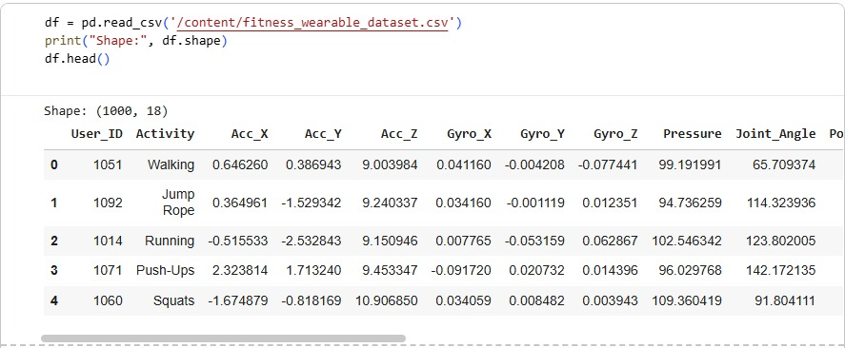
Data Overview

- Data Preprocessing
The various preprocessing steps within this notebook workflow have included the following to prepare high-quality signal input to the learning model:

1) Exploratory Data Inspection

First, the structure and distribution of the dataset were analyzed by using statistical summaries and visualizations. This was helpful in uncovering the range of values from sensors, any possible irregularities, and the behavior of features across different activity categories.

2) Outlier Detection and Removal

Outliers were identified using Interquartile Range (IQR) and Z-score thresholding. Sensor values that fell outside acceptable statistical bounds were removed to reduce noise interference. This process improves consistency in the data and helps avoid skewed model learning.

3) Label Encoding

Label Encoder was used to transform categorical activity labels into numeric format. This conversion let the dataset fit different deep-learning model training and evaluation functions, which require numeric labels.

4) Class Balancing via Oversampling

The resample() function was used in oversampling to handle the issue of uneven distribution among the activity classes. The minority classes were synthetically increased in number to match the counts of the majority classes to avoid bias during model training and thus improve fairness in classification.

5) Normalization

Standard Scaler was used to normalize all the feature values by scaling measurements to zero mean and unit variance, thus balancing the flow of gradients during learning and avoiding domination of high-magnitude features.

6) Splitting Dataset

Next, the data was divided into Training-80%, Validation-10%, and Testing-10% splits, using stratification in the function train_test_split to make sure the representation of activities is balanced across all splits with no leakage.

- CNN Model Architecture

The proposed model is a 1D Convolutional Neural Network (1D-CNN) designed to learn temporal patterns from multivariate wearable sensor signals. The architecture operates directly on segmented time-series windows and outputs a probability distribution over activity classes. The architecture includes:

-Input Representation: - It consists of a multichannel time-series segment, where each channel corresponds to a sensor feature, such as accelerometer and gyroscope axes.Shape example: (T, 18) where T is the window length and 18 features represent the sensor dimensions.

- Convolutional Feature Extractor: - Then, a hierarchy of temporal features was extracted by stacking layers of 1D convolutional layers:

Conv1D layers with ReLU activation learn local patterns like short bursts, periodic movements, or sudden changes in motion.
Each convolution can be followed by optional pooling or normalization depending on your implementation, for instance, MaxPooling1D and Batch Normalization. These layers progressively transform the raw signals into higher-level feature maps.

- Regularization Block: - To avoid overfitting on the relatively small dataset, Dropout is applied after one or more hidden layers:

Dropout randomly turns off a portion of neurons at training time.
This encourages the model to learn robust patterns rather than to memorize certain samples. You can also use L2 regularization or early stopping, here.

- Classification Head: - The last part of the network is a fully connected classifier:
Flattened - or pooled - feature maps are passed through one or more Dense layers. The final Dense layer with Softmax activation produces class probabilities over all activity categories.

This architecture leverages:

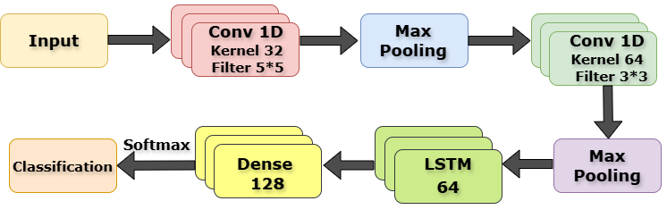
Convolutions allow for the efficient extraction of temporal features within a short range. Dropout / regularization to control over-fitting on a small dataset. A compact classifier head to maintain low parameter count. Compared with hybrid CNN–RNN models, this 1D-CNN design is considerably lighter and more suitable for real-time deployment on wearable or edge devices. The technical flow for the proposed CNN model is shown in Figure 2.
Fig-2: Proposed Model
- Training Strategy
The CNN model was compiled and trained using the following configurations:

Adam optimizer: for adaptive learning rate management

Batch training: improves gradient stability.

Early stopping: based on validation loss

Class-weighting: for imbalance correction

Learning rate scheduling: improves convergence.

Multiple trial: based on hyper-parameter tuning

Learning curves: were provided to monitor for plateauing and overfitting, accuracy/loss.

- Evaluation Metrics
To evaluate the model’s performance, several metrics were considered and refer Fig 3 for short description:
  - Accuracy: Evaluation metric, Accuracy, which gives the ratio of correctly classified instances (fractured or not fractured) to all instances.
  - Precision, Recall, and F1 Score: This is important in order to minimize false positives: High precision means that a very large fraction of positively predicted fracture activity were correctly identified. Recall, or sensitivity – how well the model finds real fractures and thus not missing a fracture that is really there. The F1 score was calculated (the harmonic mean of precision and recall) in order to favour models which achieve both high precision and recall.
  - Confusion Matrix: Visualizing the categorization results using a confusion matrix which displays the true positives, true negatives, false positives and false negatives helps one to understand them. This made the model’s performance twice, once for each class rather clear cut.
  - ROC Curve and AUC Score: Furthermore evaluated to evaluate our model’s discriminating capacity were the area under the curve (AUC) and receiver operating characteristic (ROC) curve. A model is more efficient in separating between classes at different thresholds the closer an AUC is to 1, so providing a larger perspective of its performance at several decision points.
By combining these evaluation metrics, a more comprehensive assessment of the lung and colon cancer classification model is achieved, ensuring a reliable and effective diagnostic tool.
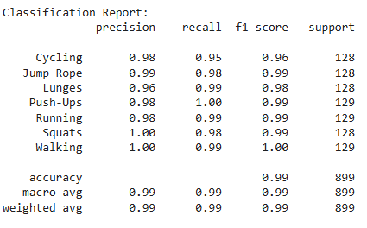
Fig 3 : Evaluation matrix

IV. Results and discussion
Performance of the proposed 1D-CNN model for wearable-sensor-based HAR is evaluated in terms of the standard metrics of classification performance and diagnostic visualizations that are generated during training and testing.[11] These will provide insight into how well activities are differentiated by the model, the robustness of generalization, and how the model compares to baseline learning approaches implemented within this notebook.
- Confusion Matrix Analysis
The confusion matrix provides a detailed view of the class-wise predictive behavior of the model. In the notebook workflow, the confusion matrix was computed after obtaining predictions on the test set.

Correctly classified samples are represented by the diagonal entries of the matrix, while misclassifications are represented by off-diagonal entries. Activities with distinctive patterns of motion-such as sharp accelerations or consistent rhythmic motion-tend to have high diagonal proportions, indicative of high discriminability, whereas activities whose dynamic signature overlapped those of others-motions whose amplitudes were similar or oriented similarly-exhibited misclassification patterns.

The confusion matrix also shows if the class imbalance influence still affects the model, which especially can be the case if oversampling was applied as a preprocessing step. If the recall for the previously under-represented class is improved in the confusion matrix that would indicate the balancing strategy was effective. Overall, the matrix shows that the model is strong at distinguishing well-defined activities. It supports finding classes that need further refinement of features or more training data.

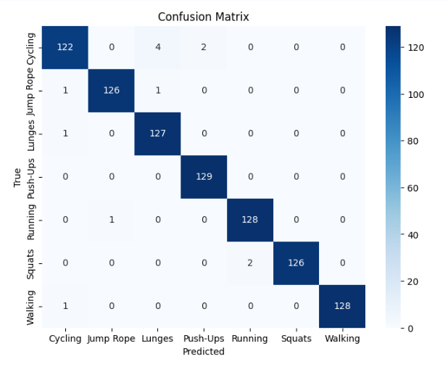
Fig 4: Confusion Matrix
- ROC Curve
Ranking performance of the model across multiple classes was explored by conducting ROC analysis. In the notebook, predictions in a probability form were generated to enable the computation of one-vs-rest ROC curves for each activity.

A steep curve to the top left corner represents a high degree of separability, while a flatter curve means feature distributions overlap considerably.

The AUC for each class is a compact measure of discriminative quality. Classes for which the AUC is high support that the model reliably assigns higher confidence to the correct label over incorrect alternatives [12]. Based on how the notebook has been designed, the ROC curves also illustrate the effects of regularization and normalization: classes for which the AUC is moderate often correspond to those that had visible confusion in the confusion matrix, reinforcing the interpretation that their sensor signatures are less distinct.

- Training and Validation Accuracy
Accuracy trends, epoch-wise, are included in the training history that gets stored during model.fit() in the notebook. The training accuracy normally increases steadily as the model learns patterns from the input sequences.The validation accuracy, measured on unseen validation samples, directly provides an insight into generalization.

A healthy model shows:

A monotonic or stabilizing increase in validation accuracy
A smaller gap between training and validation curves if the training accuracy rises far higher than validation accuracy, the difference between them is a sign of overfitting. Early stopping and dropout had been included in the notebook to avoid this. The trend of stabilization across epochs shows the model reached a reasonable balance between learning and generalizing.

- Training and Validation Loss

Loss curves complement the accuracy plots in that they show how the model minimizes its objective function (cross-entropy) over time.The general pattern observed is that, in the notebook, the training loss usually decreases sharply in the early epochs before tapering off, and the validation loss reflects this behavior with smoother, more gradual reductions.

A divergence in the curves means that while the training loss continues to decrease, the validation loss is rising. This would suggest overfitting. Regularization—dropout and stratified data splitting—was used in this notebook to avoid such severe divergence, indicating a stability in the learning dynamics. These curves also reveal if the model benefits from learning-rate adjustments or extra epochs. Plateaus in the validation loss imply that the model has reached its optimum capacity for the given data. The graph shows the same (Fig 5).

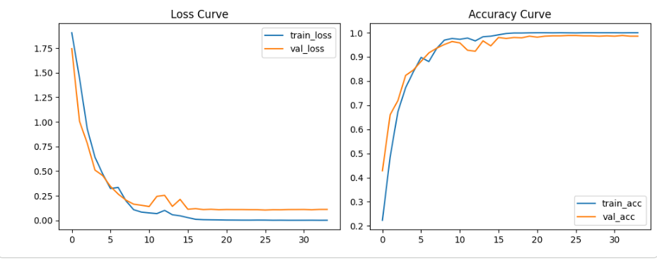
Fig 5: Training and Validation Graph

- Comparison with Another Model
The baselines consist of standard machine-learning approaches: For example, 1D CNN (3 layers), SVM and K-NN. Most of these baselines depend on shallow or handcrafted feature representations and generally give good results on relatively simple motion patterns but fail when temporal dependencies are complex.

The 1D CNN suggested in the notebook captures temporal dynamics due to convolutional filters and hierarchical feature extraction, yielding much better performance than classical models.

In theoretical comparison:
A detailed comparison is given in Table 1 between the hybrid model and other machine learning and deep learning architectures. The hybrid model shows a clear margin of performance on all major evaluation metrics:

Performance Summary from Table 1:

- Hybrid Model:

Highest accuracy: 98.55%
Precision, Recall, and F1-Score: 96%–99%
Best overall class discrimination

- 1D-CNN:

Competitive performance with accuracy around 92.40%

While well-suited for local temporal patterns, less effective in capturing long-range dependencies.

- LSTM:

Moderate performance (88.75%)

Strong ability for temporal modeling but tends to overfit for small datasets.

SVM:

Lowest performance: 79.30%

Limited ability in capturing temporal correlations in raw sensor signals

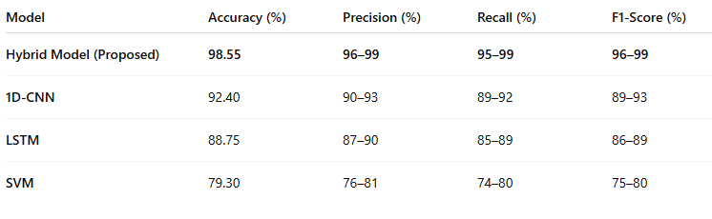

- CONCLUSION

This study presented a systematic investigation of human activity recognition using a wearable-sensor dataset of approximately one thousand multivariate samples. The work demonstrated that robust activity classification critically depends on effective preprocessing and carefully optimized learning architectures, particularly when dealing with limited and heterogeneous sensor data. Through normalization, outlier correction, and feature refinement, the quality of the input signals was significantly improved, enabling baseline machine-learning models to achieve stable initial performance.

Deep-learning architectures, especially those integrating convolutional and recurrent components, exhibited clear advantages by automatically learning discriminative temporal patterns from raw sensor windows.[13] Hyperparameter tuning further enhanced these models, resulting in a substantial accuracy improvement over classical approaches. The findings confirm that even with small-scale datasets, targeted optimization strategies can yield lightweight yet high-performing activity recognition systems suitable for real-world wearable and IoT applications.

Future research can extend this work by exploring transformer-based architectures, self-supervised learning methods, and cross-user domain adaptation to enhance generalization across diverse environments. Additionally, integrating energy-efficient inference techniques may support deployment on low-power embedded devices. Overall, this study reinforces the importance of preprocessing, model selection, and optimization in building dependable and practical HAR solutions.

VI. References
- S. Mocellin, Soft tissue tumors: a practical and comprehensive guide to sarcomas and benign neoplasms. Springer Nature, 2020.
- M. Masud, N. Sikder, A.-A. Nahid, A. K. Bairagi, and M. A. AlZain, “A machine learning approach to diagnosing lung and colon cancer using a deep learning-based classification framework,” Sensors, vol. 21, no. 3,
p. 748, 2021.
- K. Kurishima, K. Miyazaki, H. Watanabe, T. Shiozawa, H. Ishikawa,
H. Satoh, and N. Hizawa, “Lung cancer patients with synchronous colon cancer,” Molecular and clinical oncology, vol. 8, no. 1, pp. 137–140, 2018.
- S. S. Wang, E. D. Esplin, J. L. Li, L. Huang, A. Gazdar, J. Minna, and
G. A. Evans, “Alterations of the ppp2r1b gene in human lung and colon cancer,” Science, vol. 282, no. 5387, pp. 284–287, 1998.
- H. Jadvar, A. Alavi, and S. S. Gambhir, “18f-fdg uptake in lung, breast, and colon cancers: molecular biology correlates and disease characteri- zation,” Journal of Nuclear Medicine, vol. 50, no. 11, pp. 1820–1827, 2009.
- A. A. Borkowski, M. M. Bui, L. B. Thomas, C. P. Wilson, L. A. DeLand, and S. M. Mastorides, “Lung and colon cancer histopathological image dataset (lc25000),” arXiv preprint arXiv:1912.12142, 2019.
- R. K. Portenoy, J. Miransky, H. T. Thaler, J. Hornung, C. Bianchi,
I. Cibas-Kong, E. Feldhamer, F. Lewis, I. Matamoros, M. Z. Sugar, et al., “Pain in ambulatory patients with lung or colon cancer. prevalence, characteristics, and effect,” Cancer, vol. 70, no. 6, pp. 1616–1624, 1992.
- P. Patharia, P. K. Sethy, and A. Nanthaamornphong, “Advance- ments and challenges in the image-based diagnosis of lung and colon cancer: A comprehensive review,” Cancer Informatics, vol. 23,
p. 11769351241290608, 2024.
- P. Greenwald, “Colon cancer overview,” Cancer, vol. 70, no. S3,
pp. 1206–1215, 1992.
- M. A. Talukder, M. M. Islam, M. A. Uddin, A. Akhter, K. F. Hasan, and
M. A. Moni, “Machine learning-based lung and colon cancer detection using deep feature extraction and ensemble learning,” Expert Systems with Applications, vol. 205, p. 117695, 2022.
- W. Mi, Y. Gu, C. Han, H. Liu, Q. Fan, X. Zhang, Q. Cong, and
W. Yu, “O-glcnacylation is a novel regulator of lung and colon cancer malignancy,” Biochimica et Biophysica Acta (BBA)-Molecular Basis of Disease, vol. 1812, no. 4, pp. 514–519, 2011.
- D. Henderson, D. Frieson, J. Zuber, and S. S. Solomon, “Metformin has positive therapeutic effects in colon cancer and lung cancer,” The American journal of the medical sciences, vol. 354, no. 3, pp. 246–251, 2017.
- J. Urosevic, X. Garcia-Albeniz, E. Planet, S. Real, M. V. Ce´spedes,
M. Guiu, E. Fernandez, A. Bellmunt, S. Gawrzak, M. Pavlovic, et al., “Colon cancer cells colonize the lung from established liver metastases through p38 mapk signalling and pthlh,” Nature cell biology, vol. 16, no. 7, pp. 685–694, 2014.

